**Project Title:**

**Digital Analysis of Organ CT scan images for Tumour Detection**

**Team Members:**

|  |  |
| --- | --- |
| **Name** | **Registration Number** |
| Mahale Shantanu | 17BCE1161 |
| K. Gagan Sai Goud | 17BCE1262 |
| N. Sai Swaroop | 17BCE1304 |

**Abstract**

Tumour detection is one of the modalities that can be used to diagnose tumours in organs. However, this modality only captures the image without extracting the tumour completely. The process of extracting medical images is one of the most challenging fields nowadays. Most of the techniques used nowadays are more MRI modality compared to CT scan images because MRI images are of higher resolutions. Image processing techniques are widely used in several medical problems for picture enhancement in the detection phase to support the early medical treatment. In this research we proposed a detection method of organ tumor based on image segmentation. This project describes methods to detect and extract organ tumour from patients CT scan images. Image Segmentation is used to detect the tumours. The process involves the extraction and segmentation of tumour of a patient using MATLAB software.

**Keywords: -** Segmentation, Tumor, Salt & Pepper Noise, Binarize, Tomography

**Introduction**

In recent years the Image processing mechanisms are used widely in several medical areas for improving early detection and treatment stages, in which the

time factor is very important to discover the disease in the patient as fast as possible, especially in various cancer tumours such as the lung cancer. Cancer tumour have been attracting the attention of medical and static communities in the recent years because of its high prevalence allied with the difficult treatment. Early detection of such tumours is very important for successful treatment. There are very few methods available to detect such cancerous tumours. One of such popular methods is using Image Segmentation.

Interpretation of medical images is often difficult and time consuming, even for experienced physicians. The aid of image analysis and machine learning can make this process easier. The medical service has been enriched with a lot of new techniques for diagnostic imaging during the last decades. As digital technologies are incorporated in every aspect of our lives, they are also the key part of medical diagnosis. DICOM standard was developed to make sharing of medical information safe and above all standardized. DICOM images can be viewed by various available DICOM viewers. Visual information retrieval is an emerging domain in the medical field as it has been in computer vision for more than ten years. It has the potential to help better managing the rising amount of visual medical data currently produced. One of the proven application fields for CBMIR as diagnostic aid is the retrieval of lung CTs.

The diagnostics of these images depend strongly on the texture of lung tissue and automatic analysis can be a valuable help. The preprocessing step of most Computer-Aided Diagnosis (CAD) systems for identifying the lung diseases is lung segmentation. Cancer is one of most dangerous disease that causes deaths [1]. Data obtained from Global Burden Cancer shows that in 2012 there are 14.1 million cases of cancer in the world, with lung cancer occupies the first position with a percentage of 13%. While the number of cancer deaths was recorded 8.2 million deaths, with lung cancer cause of death in first place with a percentage of 19% [2]. Lung cancer is a disease of abnormal cells multiplying and growing into a tumour. Cancer cells can spread out from the lungs through the blood stream or lymph fluid that surrounds the lung tissue. Generally, cancer cells often spread toward the center of the chest due to the natural flow of lymph. Metastasis occurs when cancer cells spread to other organs. The process of early detection of cancer plays an important role to prevent cancer cells from multiplying and spreading. Previous researches have been conducted for analyzing lung cancer such as using clustering method in microarray data [3], the detection of lung cancer with general image processing techniques in CT scan data with good results and accuracy [4]. In this study we proposed and evaluated additional image segmentation methods in analyzing lung cancer using image processing techniques.

This [paper is organized as follows: in section 2, a background of previously existing work on the use of game-terrain solving approaches is provided; section 3 consists of the discussion of the proposed idea which can solve a terrain-map more efficiently than the traditional approaches of pathfinding. The observations and results of the proposed work is highlighted in section 4 with respect to the metrics used for evaluation and graphical representations of results is given. Section 5 is the last section which consists of the inferences which we can draw from the proposed work.

1. Literature Review

Many of the techniques of digital image processing, or digital picture processing as it often was called, were developed in the 1960s at the Jet Propulsion Laboratory, Massachusetts Institute of Technology, Bell Laboratories, University of Maryland. A few researches such as application to medical imaging, satellite images, wire-photo standards conversion, videophone, character recognition, and photograph enhancement were also carried out[1].

The Lung cancer is a disease of abnormal cells multiplying and growing into a tumour. Cancer cells can be carried away from the lungs in blood, or lymph fluid that surrounds lung tissue. Now several systems are proposed and still many of them are conceptual design. Artificial Neural Network based Classification and detection system of lung cancer [1-2], this system is conceptual and provide poor accuracy. Computer-aided diagnosis in chest radiography [6] has classify the lung regions extraction approaches into two different categories; either rule-based or pixel classification based category. Automatic detection of small lung nodules on CT utilizing a local density maximum algorithm [4], it is old model and provides poor detection. CADs can be divided into two groups: density-based and model-based approaches [6]. In some approaches uniformity, connectivity, and position features were extracted [5]. Lung cancer detection by using artificial neural network and fuzzy clustering methods [3], presents two segmentation method and Lung Cancer Detection Using Image Processing Techniques [7-8,11] and Early Detection and Prediction of Lung Cancer Survival using Neural Network Classifier [10] have been developed but they provide poor detection and identification. Lung Cancer Detection using Curvelet Transform and Neural Network [12], propose a new technique for LCD identification where curvelet transform can extract the features of lung cancer CT scan images proficiently. In recent year, the latest research’s work are done in the field of lung cancer detection such as Lung Cancer detection and Classification by using Machine Learning and Multinomial Bayesian [14], Lung Cancer Detection and Classification by Using Bayesian Classifier [15], Automatic Detection of Lung Cancer in CT Images [16], Lung Cancer Detection Using BPNN and SVM [17], Size Estimation of Lung Cancer Using Image Segmentation and Back Propagation [18], and Gray Coefficient Mass Estimation Based Image Segmentation Technique For Lung Cancer Detection Using Gabor Filters [19]. After surveying different research works, the objective of proposed system is to represent a fast and robust system for detecting Lung Cancer properly in early stage and our proposed system provide more accuracy than many other existing techniques.

1. Methodology/Proposed Work

The methodology can be briefly divided into several parts:

* 1. ***Identify type of noise***

The noise throughout most of those pictures is usually noted to as salt and pepper noise. Noise of this kind consists of certain amounts of the pixels within the image either being black or white, the most common method of removing such noise is understood to be through a medium filter. Medium filtering is less sensitive than linear techniques to extreme changes in the pixel values, it can therefore remove salt and pepper noise without even reducing the sharpness of an image considerably. Therefore, the technique of medium filtering was employed in this research paper.

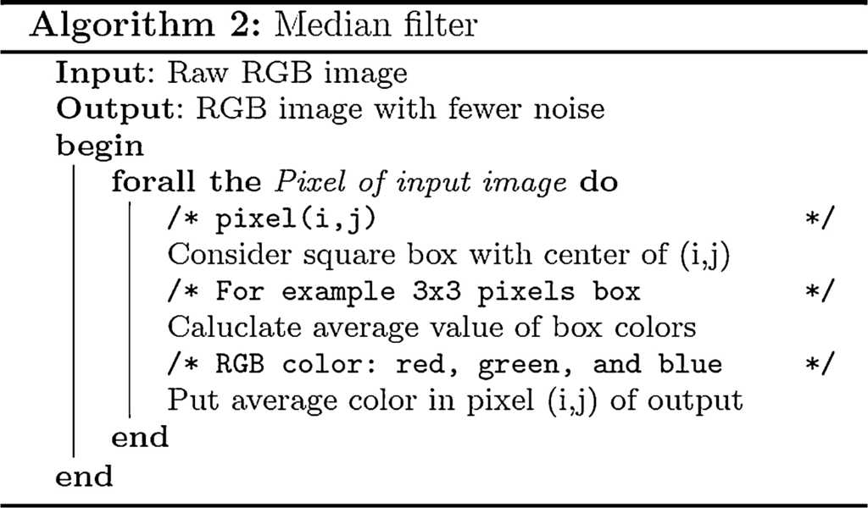

* 1. ***Input, Grayscale and Noise removal***

The problem with the initial image is the amount of noise is quite high and it needs to be removed before the other processes can be applied to extract the circles inside the image, noise can be seen in the screenshot above and causes distortion among the image in terms of brightness and darkness “Noise which varies randomly above and below a nominal brightness value”

Therefore, the primary step to providing the answer to this problem is to eventually remove any type of noise within the images inputted into the program. The primary step to this task was to scan the image into the program “select_image = imread (image_jpg);” This allows for the desired input pictures to be scanned, when the image is scanned it’s then converted from RGB to grayscale using the rgb2gray function, this allows for the removal of hue and saturated information while allowing for the ability to keep the images desired luminance. Once the image has been read and converted, then the noise can be removed.

The noise is removed using the medium filtering, this is done through a separate function called “customfilter” The function applies a medium filter to the grayscale image, which then allows for each outputted pixel to contain a medium value in the 3-by-3 region around the corresponding pixels within the image. The medium filter follows a similar approach to that of smoothing techniques, the technique of using corresponding pixels allows for the better ability of the removal of noise without reducing the sharpness of an image therefore making this the appropriate function to reduce the salt and pepper noise within the images for this assignment.

After the noise has removed the image is then implemented into a subplot to output the image with its corresponding input image, this is done throughout the project to all later images implemented within the project, an example of the noise removal and subplot is shown above.

* 1. ***Converting the Greyscale Image to a Binary Image***

The next key step to solving the problem is to convert the current greyscale image into a binary image. The reason behind converting the image into a binary image is it allows for the better ability to detect objects within an image (circles) the reason behind this is due to the fact now only two different colours exist within the image (black, white).The image is converted into a binary image by using the im2bw function “binary_picture = im2bw(median_filtering_Image, 0.2);” This function uses the filtered image as an input and then converts the pixels within the image dependent upon the luminance level of each pixel to either the value 1 (white) or the value 0 (black).

* 1. ***Create a morphological structuring element (STREL)***

This step involves creating a structuring element in the form of a rectangle “se1 = strel('disk', 2);” This specific function creates a flat disk shape structure where “2” specifies the radius. This is done twice to create two separate structures which are applied to the initial binary image, creating two separate images “postOpenImage_1” and “postOpenImage_2” Once these structures have been applied the first image is applied into the subplot and shown to the user while the other is saved for later image processing to help solve to problem in later stages

* 1. ***Inversion of the Opened Image***

This step involves the inversion of the binary image which is completed by simply using a ones function, this function basically creates an array of all ones, this is implemented to the binary image “inverted = ones(size(binary_picture));” Once this is done the following is implemented “invertedImage_1 = inverted - postOpenImage_1;” This line basically takes the inverted image with the array of ones and takes the Open image from this which in turn inverts the image by swapping all previous 0 pixels to 1 pixels and 1 pixels to 0, creating an inverted image as shown above. This is completed to allow for segmentation to be completed in the following step to allow for the program to better find the circles within the image.

* 1. ***Creating an initial Contour and implementing segmentation***

This step initially involves creating and specifying the initial contour “mask = zeros(size(invertedImage_1)); mask(50:end-50,50:end-50) = 1;” The mask is a binary image that specifies the initial state of the active contour, this involves the boundaries of the images regions in this case the white background and black regions outside the main part of the Image, this all allows for contour evolution to occur to allow for segmentation of the image to occur. Once the image is segmented it will produce a clearer way of finding the circles within the lung as this means the foreground and background no longer cause any issues when attempting to find the circles as seen above in the screenshot.

* 1. ***Combination Image and Find Circles***

The next process required is to find the circles within the lung, within this program the image is created using a combination of the inverted image and contour segmentation “mix_Image_1 = invertedImage_1 + bw_1;” This creates an initial image that the circles can be found upon, from this the image is then converted into black and white using “im2bw” then the final image uses the medium filter “medfilt2” to further filter the image to allow for the best possible ability to find any circles within the lung.

The main process within this step is now to find the circles this is done using the imfindcircles function “[centers,radii] = imfindcircles(final_1,[1 9],'ObjectPolarity','dark','Sensitivity',0.88); This function looks for dark sensitivity within the above image using the parameters of centres and radius with a sensitivity specification, from this the circles are then displayed using green circles “viscircles(centers,radii,'EdgeColor','g'); “ After this is completed the image is then displayed as seen above in the screenshot with the circles all being highlighted in green.

The circles are also counted “display(size(centers, 1), ' Numbers of Circles');” this allows for all circles found to have a centre to be counted and outputted into the command window.

* 1. ***Segment Circles***

After the circles have been counted and found the circles need to be Segmented and then detected. This is done by firstly creating a segmented picture “segment_pic = final_2 - final_1;” This is done by taking an image without the circles located to a picture with the circles located, therefore leading to an image with the circles completely segmented away from the image resulting in a precise way to find the boundaries of each circle “[B] = bwboundaries (pre_ color_pic, 'holes');“

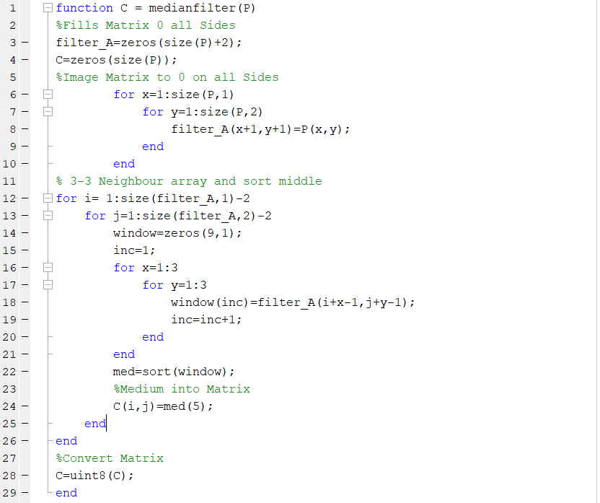

This code primarily

This code finds all circles within the image and therefore the boundaries and then colors each circle with a fill of green to identify they have been found as seen in the screenshot above. Therefore solving all problems indicated within the brief as the circles have been counted found and all noise has been removed.

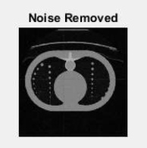

**Noise Removal:**

The noise is identified to be Salt and Pepper Noise and is removed by using the process of Median Filtering.

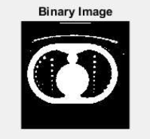

**Binary Image:**

The Grayscale image is converted to binary image to allow better ability to detect the tumour within the image.

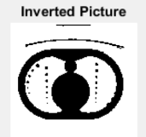

**Inverting Image:**

The values of pixels are stored in an array. A function called ones() is used to convert all the pixels storing one to zero and those storing zero to ones.



**Segmenting Image:**

We create the initial contour. A mask is made which specifies the initial state of the contour allowing contour evolution to occur for segmentation of image.



**Finding Circles:**

To find the circles within the image, an image is created using a combination of inverted image and contour segmentation.



**Circle Found Picture:**

We find the circle found picture using a combination of the inverted image and contour segmentation which creates an initial image that the circles can be found upon.

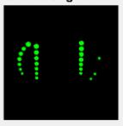

**Circles Segment:**

After finding and segmenting a circle and is done by taking a picture without the circles located to a picture with the circles located to a picture with the circles located, leading to an image with circles totally segmented away.

**Final Output** (sequentially showing the undertaking of each of the aforementioned processes) **:**

The coding of the given algorithm was done in MATLAB because of the extensive variety of library functions present in it and great ease in use for performing tasks related to Image Processing.

1. Results and Discussion

In the context of medical image analysis, providing quick and precious information to the clinician is not limited to automatic recognition of abnormal tissue and/or structure. Conventional methods of lung segmentation that rely on large gray value contrasts between lung fields and surrounding tissues fail on dense pathologies. The proposed study shows that automatic segmentation eliminates the tasks of finding an optimal threshold and separating the attached left and right lungs, which are two common practices in most lung segmentation methods and require a significant amount of time. We have applied segmentation tools on several pulmonary CT images. Experiments results show that the proposed method can improve the speed, robustness and accuracy of diagnosis as physician can judge a particular case in right time and with full information of pathology. Content–based medical image retrieval (CBIR) aims at finding objectively visually similar images in large standardized image collections such as PACS [9].

The notion of similarity is usually established from a set of visual features describing the content of the images. Fig: 6 3D view of MATITK result for ten slices. Few CBIR systems have been evaluated in clinical practice but some of them showed that they can be accepted by the clinicians as a useful tool [10] [11]. The aid of image analysis and machine learning can make this process easier. The medical service has been enriched with a lot of new techniques for diagnostic imaging during the last decades. As digital technologies are incorporated in every aspect of our lives, they are also the key part of medical diagnosis. DICOM standard was developed to make sharing of medical information safe and above all standardized. DICOM images can be viewed by various available DICOM viewers.

The use of a CBIR system clearly increased the number of correct diagnoses. A possible extension to CBIR is to carry out case–based retrieval. In this paper we show that automated lung classification in CT data is complementary to case–based retrieval, both from the user’s viewpoint and also on the algorithmic side. Based on the volumes of the segmented tissues and a set of selected clinical parameters, similar cases can be retrieved from a database of lungs. Future work will include incorporation of segmentation results in CBMIR system and modification of similar segmentation tools to develop a more consistent definition of the lung contours.

1. **Conclusion**

In this project, the extraction of the tumor and the size of the interested tumors successfully obtained through a few steps in the MATLAB coding for image processing. We were also able to segment the different part of the brain from the brain CT mages. By calculating the area, we can know that there are slight differences between the sizes of the tumor for different slice of brain images. The tumor was successfully extracted from the image using segmentation processing algorithm. Besides, the volume of the tumor can be calculated after the segmentation had been done but still need more testing on the accuracy.

This technique can make the operator or medical doctor easier as it would determine the level of the tumor growth instantaneously. Compared to other research, this technique is much easier to use on CT scan image. Most of the processing of the brain tumor before was focused on the MRI image which is higher resolution. Thus, the technique suggests on this project provide an alternative to make used of CT images of brain specifically.

For the future works, it is recommended to find the error percentage for the volume calculated. Besides, some improvement should be made to increase the accuracy of the area calculated.

1. **Acknowledgement**

This paper has consumed a great deal of work, findings and enthusiasm. Still it’s implementation was never possible if I didn’t have had the support of my Image Processing teacher Dr G. Malathi. Therefore, I would like to extend my sincere gratitude to Professor Dr G. Malathi for his important suggestions and help.

1. **References**
2. Chan, R. H., Ho, C. W., & Nikolova, M. (2005). Salt-and-pepper noise removal by median-type noise detectors and detail-preserving regularization. IEEE Transactions on image processing, 14(10), 1479-1485.
3. Pal, N. R., & Pal, S. K. (1993). A review on image segmentation techniques. Pattern recognition, 26(9), 1277-1294 .
4. Al-Kadi, O. S., & Watson, D. (2008). Texture analysis of aggressive and non-aggressive lung tumor CE CT images. IEEE transactions on biomedical engineering, 55(7), 1822-1830.
5. Al-Ashwal, R. H., Supriyanto, E., Rani, N. A. B., Azmira, N., Abdullah, B., Aziz, N. I., & Mahfooz, R. B. (2012). Digital processing for computed tomography images: brain tumor extraction and histogram analysis. In Math Comput Contemp Sci. 14th International Conference on Mathematical Methods and Computational Techniques in Electrical Engineering (MMACTEE13) (Vol. 26, pp. 119-28).
6. Gonzalez, R. C., Woods, R. E., & Eddins, S. L. (2004). Digital image processing using MATLAB (Vol. 624). Upper Saddle River, New Jersey: Pearson-Prentice-Hall.